A

Project Report On

**“WATCH CATALOGUE”**

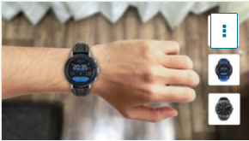

**Prepared by**

18DCS007 | RUDRA BARAD

18DCS064 | ANJALI PATEL

**Under the Supervision of**

Ms. Krishna Patel

**A Report Submitted to**

Devang Patel Institute of Advanced Technology And Research

Charotar University of Science & Technology (CHARUSAT)

Bachelor of Technology (B.Tech) in

Computer Science & Engineering (CSE)

for Partial Fulfillment of the Requirements for the

5th Semester Software Group Project-III(CS348)





**Charotar University Of Science And Technology**

**At: Changa, Dist: Anand – 388421**

**October, 2020**



**CERTIFICATE**

This is to certify that the report entitled “**Watch Catalogue**” is a bonafide work carried out by **Mr. RUDRA BARAD | 18DCS007** under the guidance and supervision of **Ms. KRISHNA PATEL** for the subject **CS348** | **Software Group Project-III** (CSE) of 5th Semester of Bachelor of Technology in **DEPSTAR-CSE** at Faculty of Technology & Engineering- CHARUSAT, Gujarat.

To the best of my knowledge and belief, this work embodies the work of candidate himself, has duly been completed, and fulfills the requirement of the ordinance relating to the B.Tech. Degree of the University and is up to the standard in respect of content, presentation and language for being referred to the examiner.

|  |
| --- |
| Ms. Krishna Patel  (Asst. Professor cum Research Fellow)  Department of Computer Science & Engineering  DEPSTAR, CHARUSAT, Changa, Gujarat |
| Dr. Amit Ganatra  Principal, DEPSTAR  Dean, FTE  CHARUSAT, Changa, Gujarat.  Prof. Parth Goel  I/C Head of Department  Department of Computer Science & Engineering DEPSTAR, CHARUSAT, Changa, Gujarat | |

**ABSTRACT**

Technology today has changed our outlook the way we experience this real world. In couple of years’ technologies has changed how we do small and large number of things. Technology came out with new advance level where user can virtually visualize the object in the real world. Augmented Reality is here with many solutions and offers user engagement to its extreme level.

For example, during this pandemic we all have learned to get digitalized.

Considering the current scenario, we thought of creating an application that can benefit users. Augmented Reality is so much popular right now!

According to the recent reports, Augmented Reality is going to be a billion-dollar industry by 2021. So, keeping both the points in mind we decided why not create an Augmented reality application through which one can easily try different watches virtually at home without visiting the shop and maintaining social distancing. So, this is how we came up with the idea of “Watch Catalogue” app.

Likewise, virtual Watch Catalogue is another innovative solution that lets user use augmented reality to try on various model of watch using colored sport wrist bands. Actually, user don’t have to rush to buy watch form outlets. Users just need to install the respective watch app.

**ACKNOWLEDGEMENT**

I, the developer of the project “Watch Catalogue”, with immense pleasure and commitment would like to present the project assignment. The development of this project has given me wide opportunity to think, implement and interact with various aspects of management skills as well as the new emerging technologies.

Every work that one completes successfully stands on the constant encouragement, good will and support of the people around. I hereby avail this opportunity to express my gratitude to number of people who extended their valuable time, full support and cooperation in developing the project.

I express deep sense of gratitude towards our Head of the CSE Department, Prof. Parth Goel and project guides Prof. Krishna Patel for the support during the whole session of study and development. It is because of them, that I was prompted to do hard work, adopting new technologies.

I would also like to thank all the mentor for their guidelines throughout the development phase of the project. They encouraged me to look forward to learn and implement new and emerging technologies. They also guided me to go for some user friendly and extremely useful real-life application.

They altogether provided me favorable environment, and without them it would not have been possible to achieve my goal.

**INDEX**

|  |  |  |
| --- | --- | --- |
|  | **Certificate**  **Abstract** | **2**  **3** |
|  | **Acknowledgement** | **4** |
| **1.** | PROJECT DEFINITION | **6** |
| **2.** | PROJECT DESCRIPTION | **7** |
| **3.** | SOFTWARE & HARDWARE ENVIRONMENT | **12** |
| **4.** | SYSTEM FLOW CHART | **14** |
| **5.** | IMPLEMENTATION SNAPSHOTS | **17** |
| **6.** | PROJECT OUTCOMES | **22** |
| **7.** | CURRENT SYSTEM & ENHANCEMENTS | **24** |
| **8.** | LIMITATION OF PROJECT & FUTURE SCOPE | **26** |
| **9.** | REFERENCES | **28** |

**CHAPTER 1: PROJECT DEFINITION**

**AR Watch Catalogue App which works on principles of Augmented Reality**

**CHAPTER 2:**

**PROJECT DESCRIPTION**

**2.1 PROJECT OVERVIEW:**

The era of flat-screen view e-commerce is over. Today users want to have better consumer experience, they want to be sure that they buy what they really like.

Watch Catalogue brings you the ability to display a 3D watch thanks to the augmented reality.

So you can easily try different colours and sizes directly on your wrist.

Experience top watches on your wrist and find your perfect fit with Augmented Reality. Trying on watches online is easy.

Simple steps to try on the watch virtually:

1. Open the Watch Catalogue app.

2. Point your phone at the wristband which consist of particular image target

3. Try different models of watch on your wrist

**2.2 INTRODUCTION TO DOMAINS:**

**Augmented Reality**

Augmented reality is defined as "an enhanced version of reality created by the use of technology to add digital information on an image of something."

AR is used in apps for smartphones and tablets. AR apps use your phone's camera to show you a view of the real world in front of you, then put a layer of information, including text and/or images, on top of that view.

**Virtual Reality**

Virtual Reality is defined as "the use of computer technology to create a simulated environment". When you view VR, you are viewing a completely different reality than the one in front of you.

Virtual reality may be artificial, such as an animated scene, or an actual place that has been photographed and included in a virtual reality app. With virtual reality, you can move around and look in every direction -- up, down, sideways and behind you, as if you were physically there.

You can view virtual reality through a special VR viewer, such as the Oculus Rift. Other virtual reality viewers use your phone and VR apps, such as Google Cardboard or Daydream View.

**Android**

Android is a [mobile operating system](https://en.wikipedia.org/wiki/Mobile_operating_system) based on a modified version of the [Linux kernel](https://en.wikipedia.org/wiki/Linux_kernel) and other [open source](https://en.wikipedia.org/wiki/Open-source_software) software, designed primarily for [touchscreen](https://en.wikipedia.org/wiki/Touchscreen) mobile devices such as [smartphones](https://en.wikipedia.org/wiki/Smartphone) and [tablets](https://en.wikipedia.org/wiki/Tablet_computer). Android is developed by a consortium of developers known as the [Open Handset Alliance](https://en.wikipedia.org/wiki/Open_Handset_Alliance) and commercially sponsored by [Google](https://en.wikipedia.org/wiki/Google).

It is [free and open source](https://en.wikipedia.org/wiki/Free_and_open_source) software, its source code is known as Android Open Source Project, which is primarily licensed under the [Apache License](https://en.wikipedia.org/wiki/Apache_License).

**2.3 APPROACH TO PROBLEM :**

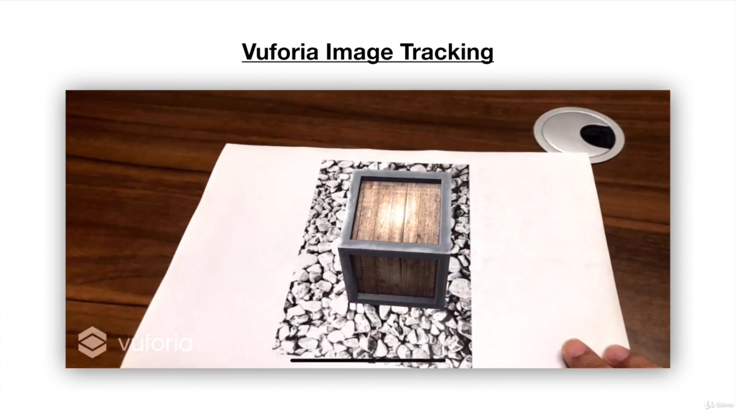

VUFORIA IMAGE TRACKING

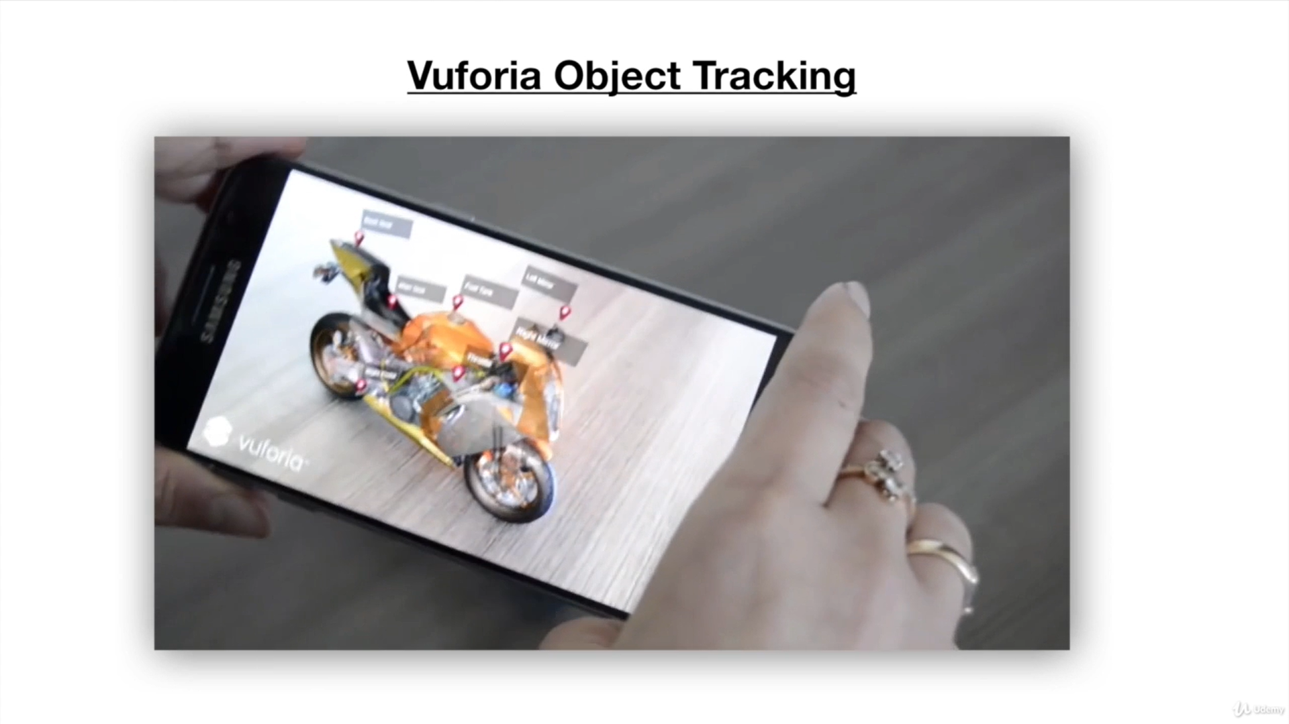

VUFORIA OBJECT TRACKING

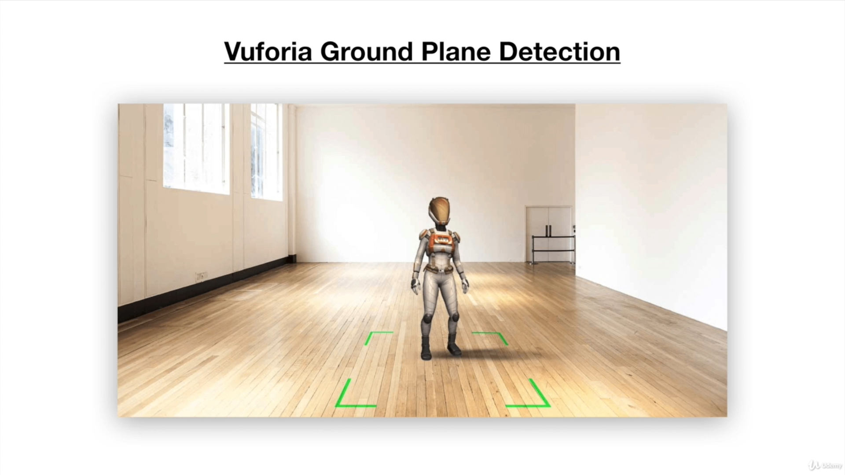

VUFORIA GROUND PLANE DETECTION

**VUFORIA IMAGE TRACKING**

Image Targets represent images that Vuforia Engine can detect and track. The Engine detects and tracks the image by comparing extracted natural features from the camera image against a known target resource database. Once the Image Target is detected, Vuforia Engine will track the image and augment your content seamlessly using best in market image tracking technology

Common uses of Image Targets include recognizing and augmenting printed media and product packaging for marketing campaigns, gaming, and visualizing products in the environment where the product was intended to be used.

The Image Targets [sample](http://developer.vuforia.com/downloads/samples) app represents Vuforia’s core features and can be a great starting point to help you implement and configure Image Targets in an application.

**CHAPTER 3:**

**SYSTEM ENVIRONMENT**

**3.1 HARDWARE AND SOFTWARE THAT WERE USED IN THIS PROJECT :-**

**SOFTWARE USED:**

* Unity Hub
* Android (C#)
* Vuforia package
* Visual Studio / Sublime Text

**SYSTEM CONFIGURATION ON WHICH THE PROJECT WAS DEVELOPED:**

* Laptop/computer with Core i5 8TH gen. Processor
* 2BG Hard Disk Storage
* 8 GB RAM

**OTHER REQUIREMENTS:**

* Vuforia Developer Portal
* DutchFree 360 Volume II

**CHAPTER 4:**

**FLOWCHART**

**CREATING CORE FUNCTIONALITY**

Select Target Image

Adding Occlusion

Adding Watch models to Image Target

Adding and Setting up Watch models in Unity

Dial

Band

Glass

Back

Buckle

Sewing

Adding Reflections

**CREATING APP UI & ADDING FUNCTIONALITY**

Adding Animations

Creating Watch Window

Created Watch Options

Name

Image

Price

Colour Palette

Close Button

Adding C# Script to make the application Interactive

Watch Button

Colour Button

Close Button

Testing Functionality and Features of application

**CHAPTER 5:**

**IMPLEMENTATION SNAPSHOTS**

**OF PROJECT**

**WATCH MODEL**

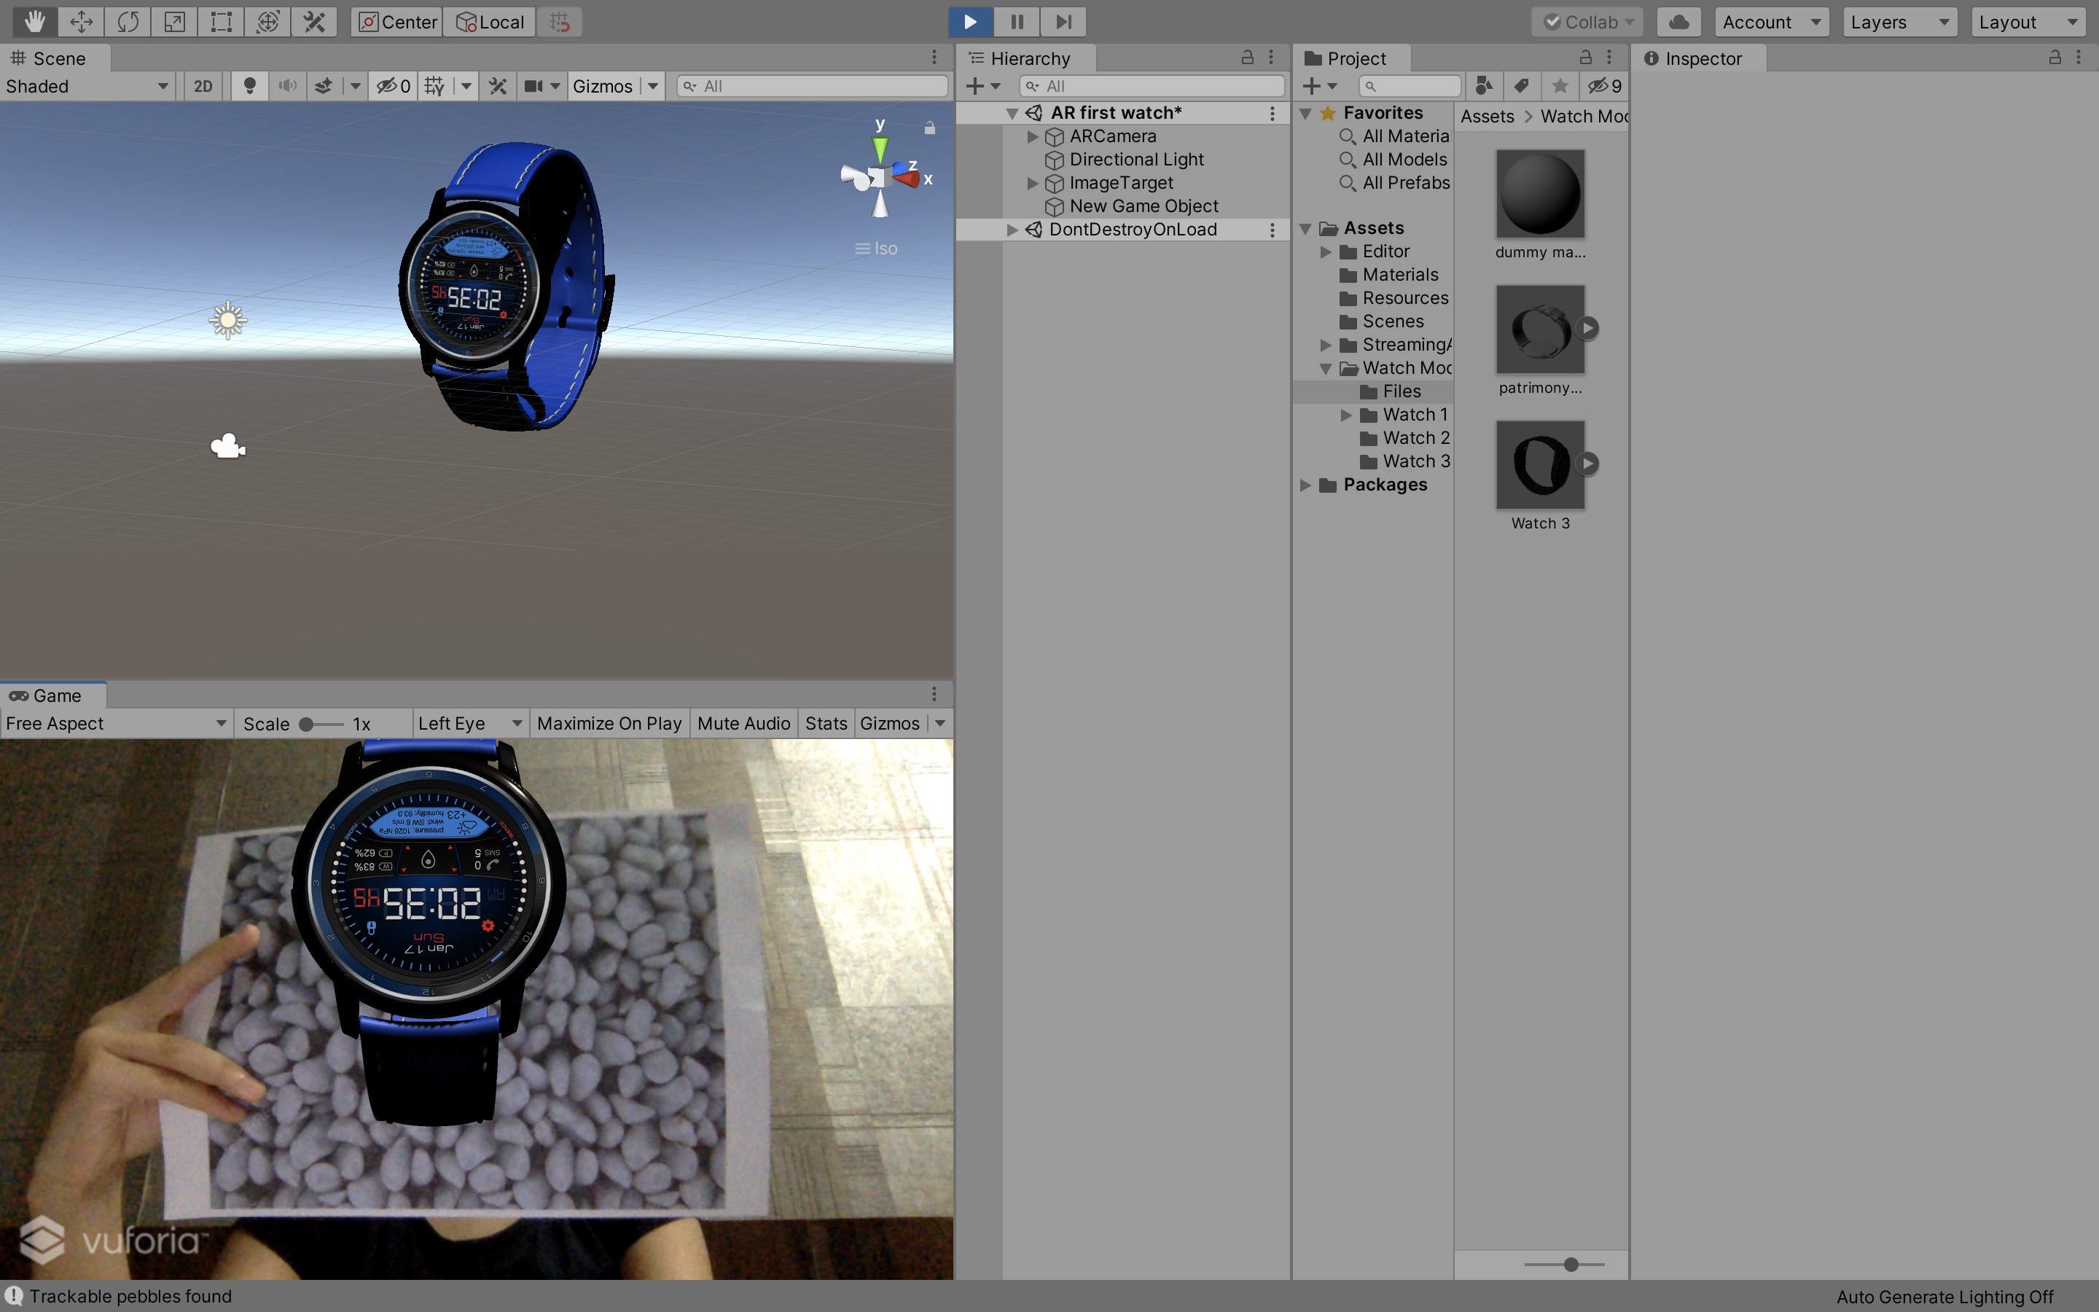

**ADDING OCCLUSION**

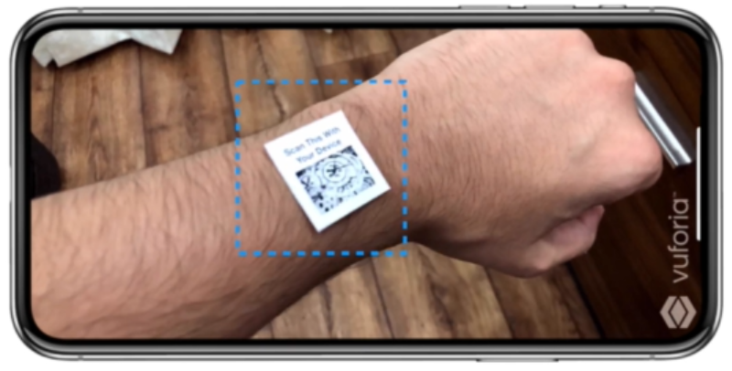

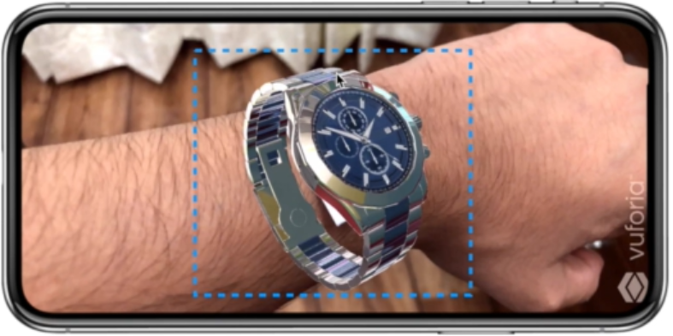

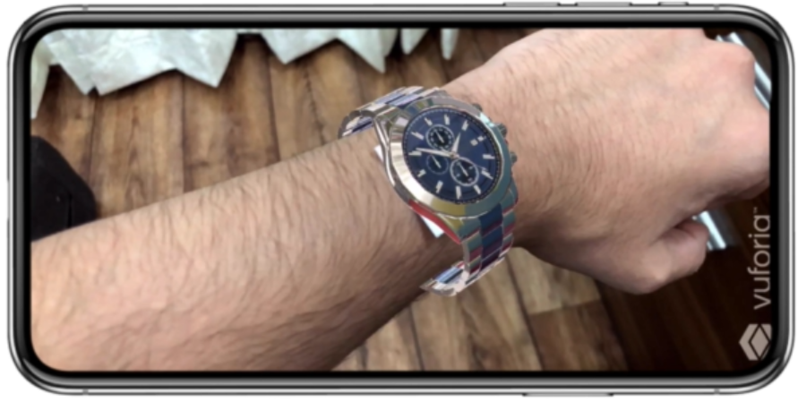

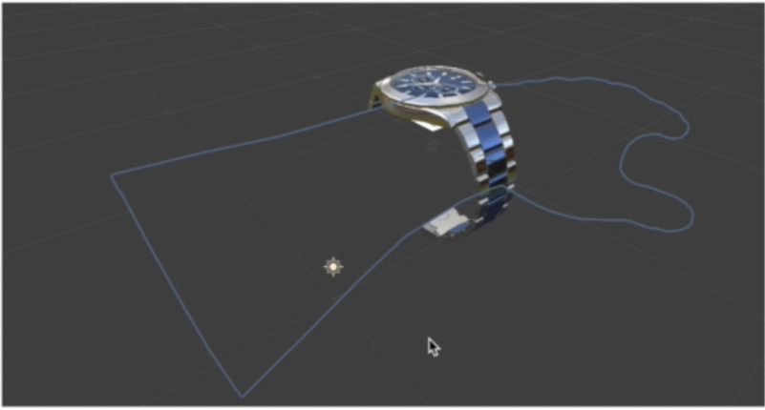

**APPLICATION UI**

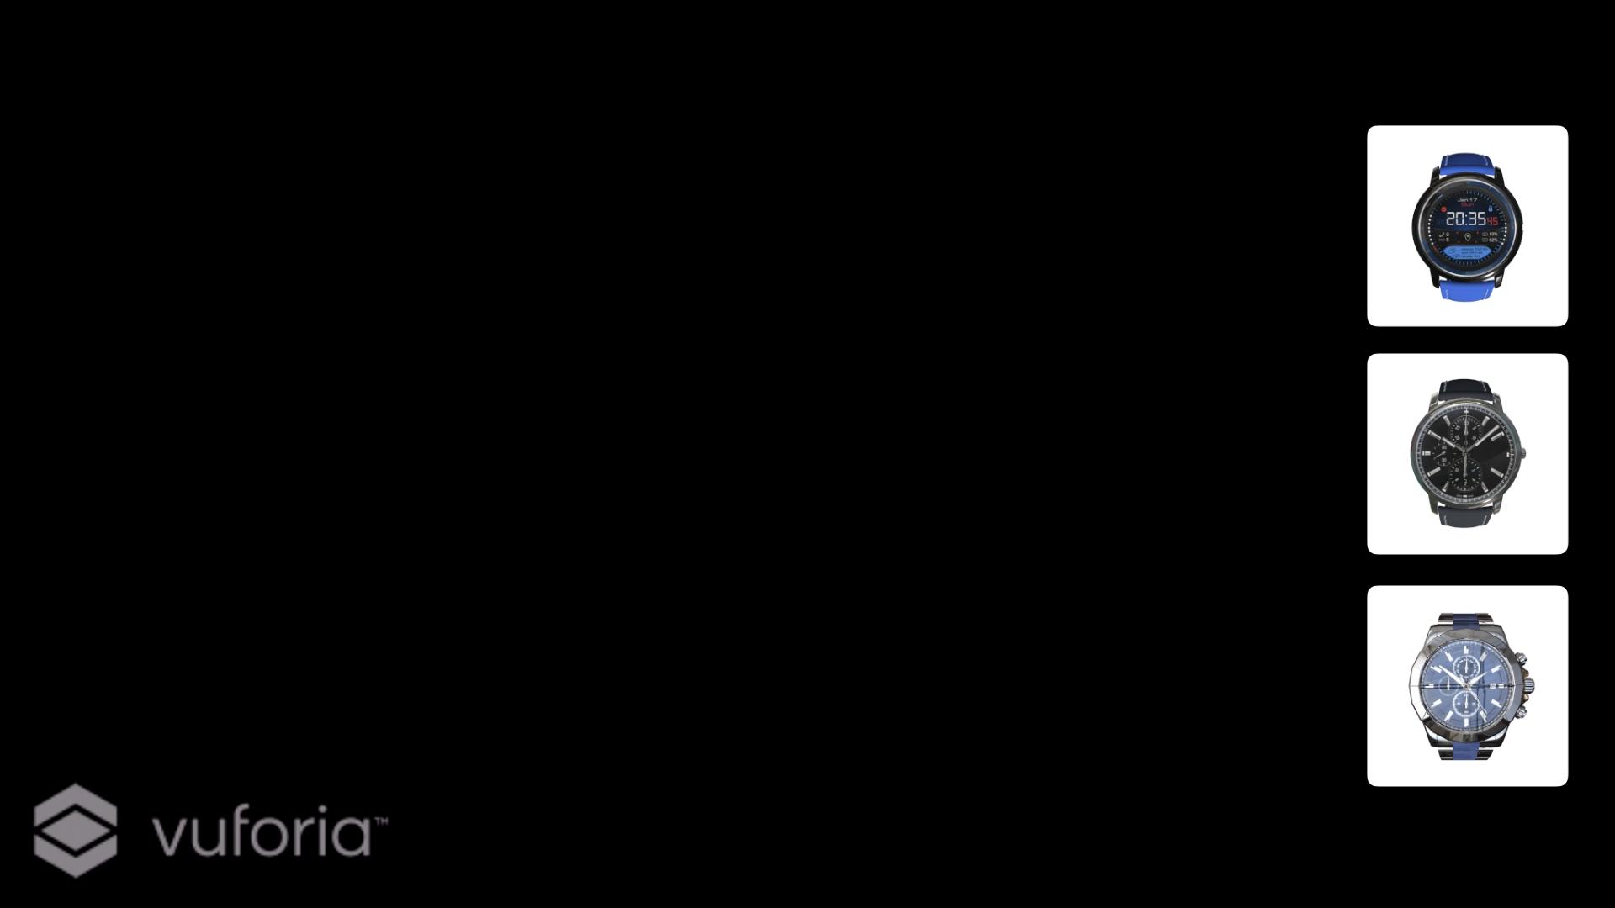

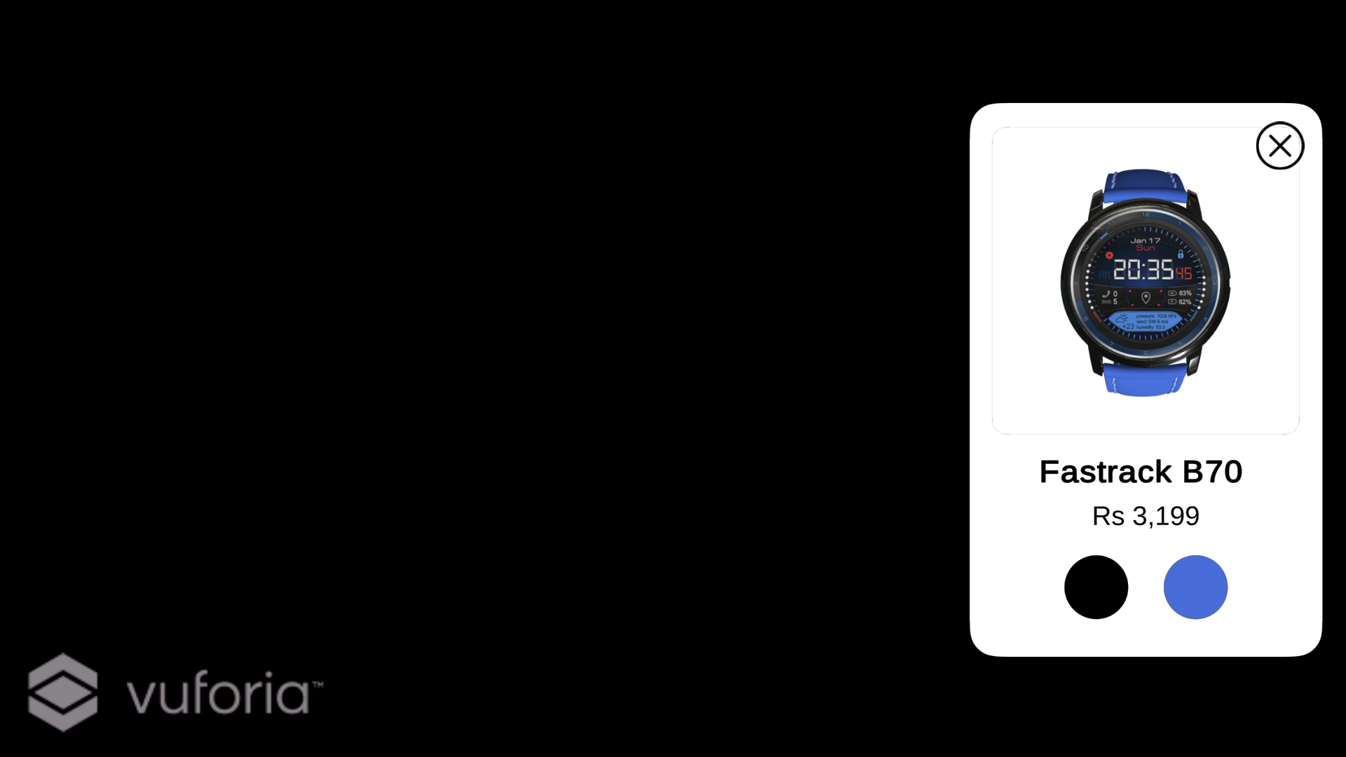

**WITHOUT REFLECTION**

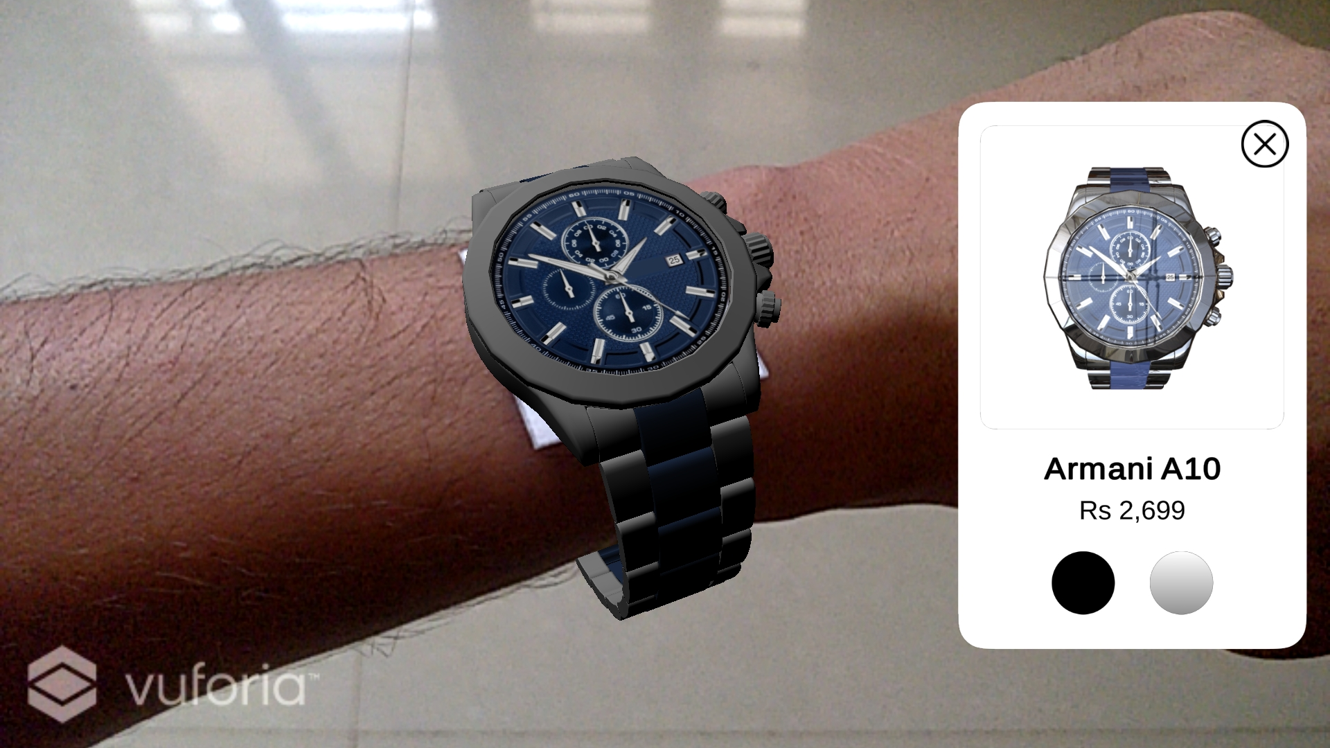

**WITH REFLECTION**

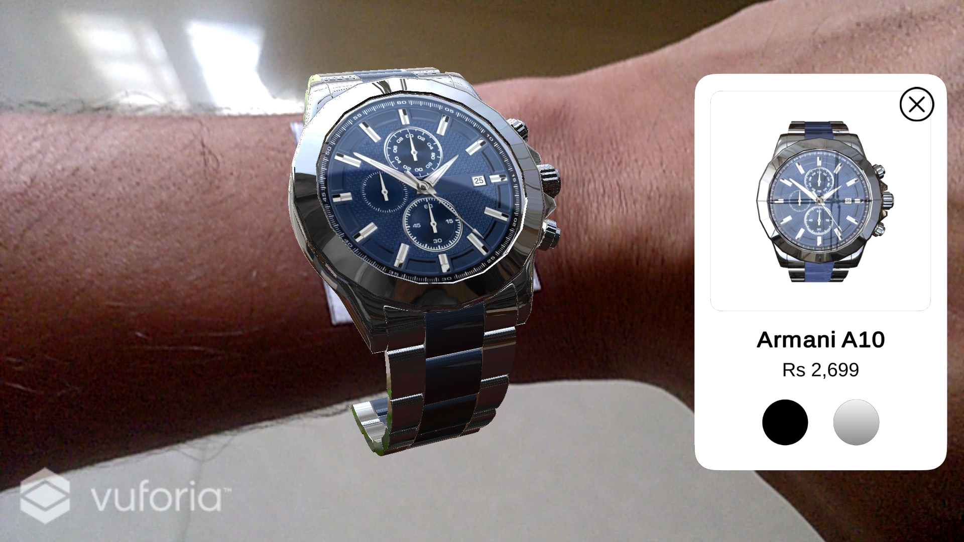

**CHAPTER 6:**

**PROJECT OUTCOME**

**Enhancing the Business**

Virtual Watch Catalogue gives an exclusive to the user to visualize the product any time. Generally, it is seen that watch can be bought from the online eCommerce platform. But users are not fully satisfied as they are in doubt whether the watch will suit or not.

Access to a vast collection of watches- It solution allows customers to explore a wide collection of watches with different dial, size, type, and brand. They can know beforehand where to invest their money.

**Friendly interface**

A friendly UI helps users to have one-tap access to different luxury watches and then view it from different angles.

**Easy to use**

Using an AR watch is no rocket science. All you have to do is to download and install it to your mobile phone and follow the onscreen instructions to view the watches collection.

**Saving of Quality Time**

It helps customers to save their quality time instead of going to the shop and trying different watches.

**Saving of Resources**

It reduces usage of the resources like petrol and electricity. And sometimes also saves money of the customers.

**CHAPTER 7:**

**CURRENT SYSTEMS & ENHANCEMENTS**

**CURRENT SYSTEMS:**

* It only has photos of the watches, so the model cannot be tried
* Lack of Touch and Feel of Merchandise in Online Shopping

**ENHANCEMENTS IN OUR PROJECT:**

* Real Shopping experience can be provided
* We can improve Customer satisfaction so that they can examine the originality of product

**CHAPTER 8:**

**LIMITATIONS AND FUTURE SCOPE**

* Size of hand may differ due to which customer may face problem while Virtually trying it
* We can add buying feature for the products so that they don't need to go to any other platform for purchasing
* Limited no. of models/designs are available

**CHAPTER 9:**

**REFERENCES**

1. [https://unity.com](https://unity.com/)
2. <https://readwrite.com/2019/03/28/why-you-should-use-augmented-reality-in-your-business-app/>
3. <https://www.udemy.com/course/augmented-reality-merge-cube-create-your-augmented-reality-application/>
4. <https://www.youtube.com/watch?v=MtiUx_szKbI>
5. <https://developer.vuforia.com/>
6. https://unity3d.com/learning-c-sharp-in-unity-for-beginners